REVISION HISTORY
REVISION | RELEASE DATE  (DD mmm YYYY) | DESCRIPTION | AUTHOR | REVIEWED BY | APPROVED BY
 |  |  | S Sai Rutambhara

Objective
This study material is designed to provide beginners with a clear and structured introduction to drone technology. The objectives are:
- To introduce the concept of drones (Unmanned Aerial Vehicles - UAVs).
- To explain the fundamental principles of drone operation in simple and easy-to-understand language.
- To familiarize readers with the different types and classifications of drones.
- To provide an understanding of the major drone components and their functions.
- To explain the basic principles of flight, stability, and control in UAV systems.
- To introduce the technologies used in drones, including flight controllers, GPS, sensors, cameras, and communication systems.
- To promote safe and responsible drone operation by covering safety guidelines.
- To create awareness of drone regulations, operational limitations, and compliance requirements.

Purpose of Study Material
- Provide a beginner-friendly introduction to drone technology.
- Simplify complex UAV concepts through clear explanations.
- Establish a strong foundation in drone components, systems, and operations.
- Enhance awareness of safety, regulations, and maintenance requirements.
- Demonstrate real-world applications and benefits of drone technology.
- Support learners in developing the knowledge required for safe and efficient drone usage.

Introduction to Drones/UAVs
A Drone, also known as an Unmanned Aerial Vehicle (UAV), is an aircraft that operates without a pilot onboard. It can be controlled remotely by an operator on the ground or fly autonomously using onboard computers, sensors, and navigation systems.

Drones are equipped with various components such as a frame, motors, propellers, battery, flight controller, sensors, GPS, and communication systems, which enable them to perform controlled flight and carry out specific missions. Depending on their design and application, drones can be used for aerial photography, surveying, mapping, agriculture, infrastructure inspection, disaster management, surveillance, research, and delivery services.

The ability to access hard-to-reach areas, collect real-time data, and perform tasks efficiently has made drones an important technology across numerous industries.

Drone Terminology
Drone/UAV terminology refers to the collection of technical terms, abbreviations, and concepts commonly used in the design, operation, maintenance, and regulation of drones (Unmanned Aerial Vehicles). Understanding these terms helps users, operators, engineers, and students communicate effectively and better understand drone systems and their functions.
Drone terminologies include:
- UAV (Unmanned Aerial Vehicle): The aircraft itself without a pilot onboard.
- UAS (Unmanned Aircraft System): The complete system including the UAV, ground control station, communication link, and supporting equipment.
- GCS (Ground Control Station): The device or software used to monitor and control the drone from the ground.
- Flight Controller (FC): The onboard computer that manages flight stability and control.
- ESC (Electronic Speed Controller): Regulates the speed of the motors based on commands from the flight controller.
- BLDC Motor: Brushless DC motor used to generate thrust for flight.
- Propeller: Rotating blade that converts motor power into thrust.
- GPS (Global Positioning System): Provides positioning, navigation, and location data.
- IMU (Inertial Measurement Unit): Sensor package containing accelerometers and gyroscopes used for attitude and motion sensing.
- Payload: Equipment carried by the drone, such as cameras, sensors, or delivery packages.
- Telemetry: Real-time transmission of flight data between the drone and the ground station.
- BVLOS (Beyond Visual Line of Sight): Flying a drone beyond the operator's direct visual observation.
- VLOS (Visual Line of Sight): Operating a drone while maintaining direct visual contact.
- Return-to-Home (RTH): A safety feature that automatically returns the drone to its takeoff location.

Types of Drones
- Multirotor drones: A multirotor drone is a UAV that uses two or more motor-propeller assemblies to generate lift, maintain stability, and control flight without requiring fixed wings.

Types of Multirotor drone:
- Quadcopters: A multirotor drone with four rotors that provides stable and efficient flight for general-purpose applications. Quadcopters are commonly available in X-frame and + (plus) frame configurations, with the X-frame being the most widely used.
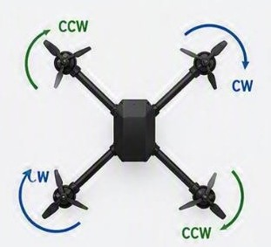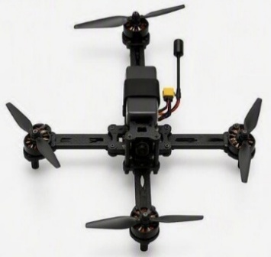
X- frame configurations Plus frame configuration
- Hexacopters: A multirotor drone with six rotors, offering greater stability, lifting capacity, and redundancy than a quadcopter.
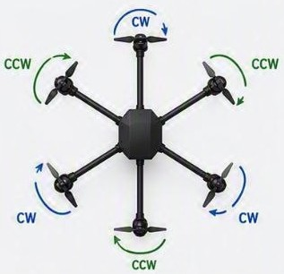
Hexacopter

- Octocopters: A multirotor drone with eight rotors, designed for heavy payloads, maximum stability, and improved flight safety.

Type | Arms | Motors | Configuration
Octo- X | 8 | 8 | X- shaped
Octo Plus | 8 | 8 | Plus shaped
X8 Coaxial | 4 | 8 | Two motors per arm
X8+ Coaxial | 4 | 8 | Plus frame, two motors per arm

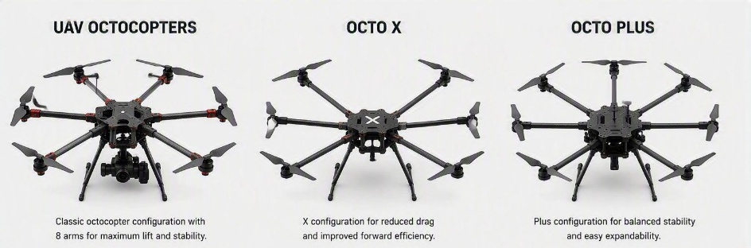 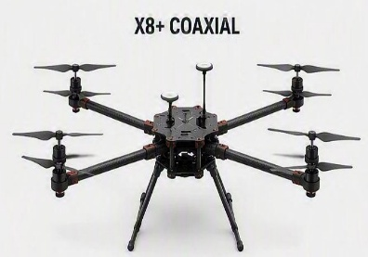 Octocopter configurations
- Fixed wing drones: An unmanned aircraft that uses wings to generate lift and is optimized for long-range, high-endurance flights.
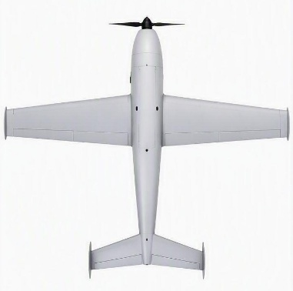
Fixed wing drones

- Hybrid VTOL drones: A hybrid drone capable of vertical takeoff and landing like a multirotor and efficient forward flight like a fixed-wing aircraft.
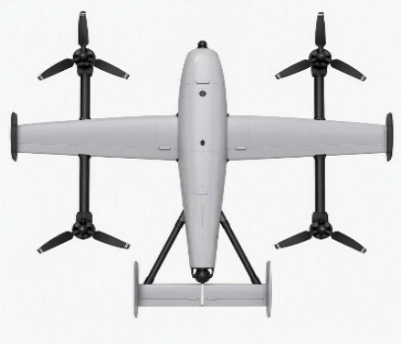
Hybrid VTOL drones

Drone Components
- Airframe: The airframe is the main structure of the drone. It supports and protects all the components mounted on it. The airframe includes Frame, Landing gear, Arms, Mounting points.

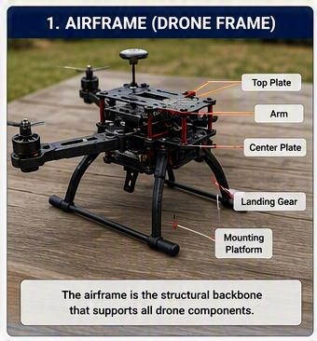
UAV Airframe

- Propeller: A propeller is a rotating blade that produces lift by pushing air downward. As the propellers spin faster, they generate more lift, allowing the drone to rise into the air. Most quadcopters have four propellers: Two rotate clockwise (CW), Two rotate counterclockwise (CCW). This opposite rotation keeps the drone balanced.

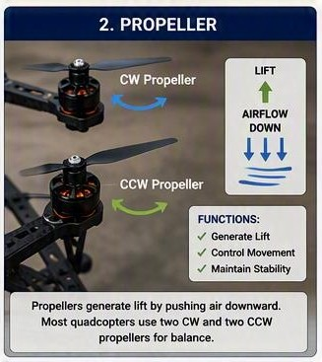
Propeller
- Brushless Motor: A brushless motor converts electrical energy from the battery into mechanical rotation. Each propeller is connected to one motor. The speed of each motor is controlled independently, allowing the drone to move in different directions. Brushless motors are preferred because they are: Efficient, Reliable, Powerful, Low maintenance.

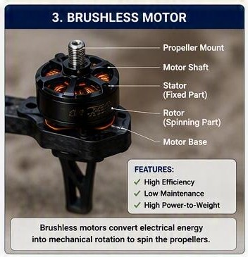
Brushless motor

- ESC: An Electronic Speed Controller (ESC) is an electronic device that controls the speed of each motor. The flight controller sends commands to the ESC, which adjusts the motor speed accordingly. Without an ESC, the motors cannot respond to pilot commands.

Classification of ESC by number of channels:

- Single ESC: Controls one motor.
- 4 in 1 ESC: Controls four motors using a single board; common in quadcopters.
- 8 in 1 ESC: A single ESC board designed to control eight motors, commonly used in octocopters to minimize wiring complexity, save space, and reduce overall weight.

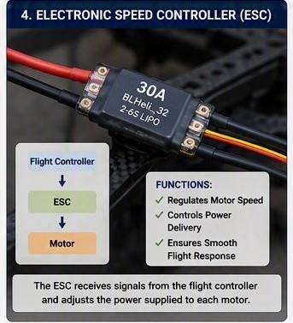
Electronic speed Controller
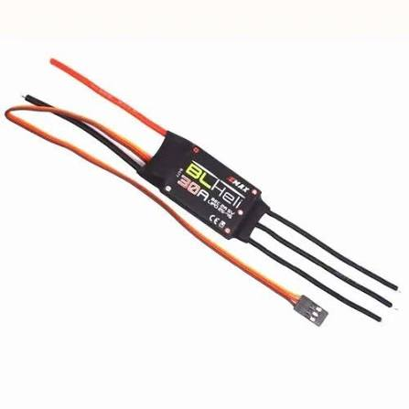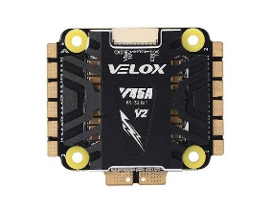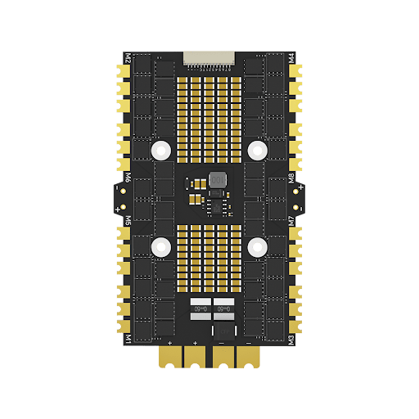
Single ESC 4 in 1 ESC 8 in 1 ESC
Classifications of ESC by number of Channels

- Flight Controller: The flight controller is often called the brain of the drone. It receives information from various sensors, processes it, and sends commands to the motors to keep the drone stable. The flight controller controls: Balance, Direction, Altitude, Navigation, Automatic flight modes.

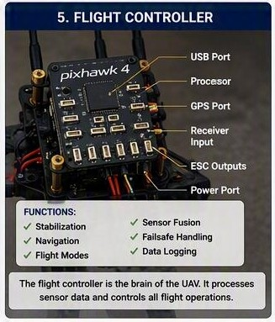
Flight Controller

- Battery: The battery supplies electrical power to every component of the drone. Most drones use rechargeable Lithium Polymer (Li-Po) batteries because they provide high energy while remaining lightweight.
Types of batteries used in UAV:

- Lithium Polymer (LiPo) Battery: The most commonly used UAV battery, known for its high power output, lightweight construction, and ability to deliver high discharge currents for demanding flight operations.
Common types of LiPo battery:
- 1S LiPo – Used in small micro and toy drones.
- 2S LiPo – Suitable for lightweight UAVs and training drones.
- 3S LiPo – Common in small to medium-sized UAVs.
- 4S LiPo – Widely used in multirotor drones requiring higher performance.
- 6S LiPo – Preferred for professional, industrial, and heavy-lift UAVs.
- 12S LiPo – Used in large UAVs with high payload and power requirements.

- Lithium High Voltage (LiHV) Battery: An advanced version of the LiPo battery that can be charged to a higher voltage per cell, providing increased power output and improved flight performance.
- Lithium-Ion (Li-ion) Battery: A high-energy-density battery that provides longer flight endurance than LiPo batteries, making it suitable for long-range and endurance UAV missions.

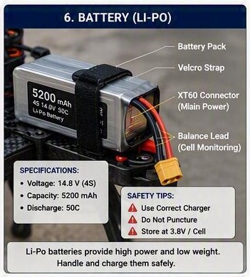
4S LiPo Battery
  - Configuration of Battery
Battery configurations are commonly represented using S (Series) and P (Parallel).
- Series Configuration: In a series connection, the voltage increases while the capacity (mAh) remains the same.
Example: 1 cell = 3.7 V, 2 cells in series (2S) = 7.4 V

- Parallel Configuration: In a parallel connection, the capacity increases while the voltage remains the same.
Example: Two 3.7 V, 5000 mAh cells in parallel, Result = 3.7 V, 10000 mAh

- Series- Parallel Configuration: A combination of series and parallel connections used to achieve both the required voltage and capacity.
Example: 6S2P configuration, if battery voltage and capacity is 3.7V 8000 mAh
Voltage: 3.7 X 6= 22.2V
Capacity: 8000 X 2= 16000 mAh
Battery rating: 6S2P 22.2V 16000 mAh

UAV Flight Controller and Sensors

A Flight Controller (FC) is an electronic circuit board containing a microprocessor and specialized software (firmware). It is considered the brain of the drone because it controls almost every aspect of flight.
The flight controller continuously:
- Receives commands from the remote controller.
- Collects data from onboard sensors.
- Calculates the drone's position and orientation.
- Adjusts motor speeds through the Electronic Speed Controllers (ESCs).
- Maintains stable flight.
- Executes automatic flight functions such as Return-to-Home and waypoint navigation.
- These calculations occur hundreds or even thousands of times each second, allowing the drone to respond almost instantly to changes in its environment.

  - Applications of Flight Controller
The primary functions of flight controller include:
- Flight Stabilization: Maintains the drone's balance by continuously adjusting motor speeds.
- Motor Control: Sends commands to the ESCs to regulate the speed of each motor.
- Navigation: Uses GPS or other navigation systems to determine the drone's position and assist with autonomous flight.
- Sensor data processing: Collects information from onboard sensors and combines it to estimate the drone's attitude, altitude, heading, and position.
- Flight mode management: Controls different operating modes such as Manual, Stabilize, Position Hold, and Return-to-Home.
- Safety Functions: Monitors battery status, communication links, and sensor health, and initiates failsafe actions when necessary.
- Telemetry: Transmits flight data, such as battery level, altitude, speed, and GPS position, to the ground control station.

  - UAV Sensors
Sensors allow the drone to "sense" its environment and its own movement. Each sensor measures a specific physical quantity, and together they provide the information needed for stable flight.

    - Inertial Measurement Unit (IMU)
The Inertial Measurement Unit (IMU) is one of the most important components of a drone. It is a combination of sensors—typically a gyroscope and an accelerometer, and sometimes additional sensors—that measure the drone's motion and orientation.
The flight controller uses IMU data to maintain balance, estimate attitude, and respond quickly to changes in movement.
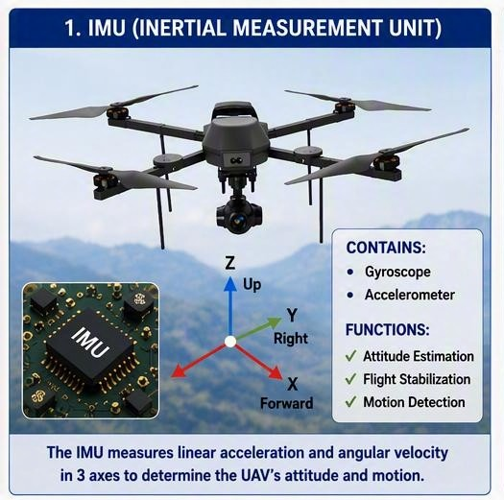
Inertial Measurement Unit
    - Gyroscope
The gyroscope measures angular velocity, which is the rate at which the drone rotates around its three axes:
- Roll
- Pitch
- Yaw
The gyroscope helps the flight controller detect unintended rotations and make rapid corrections to keep the drone stable.
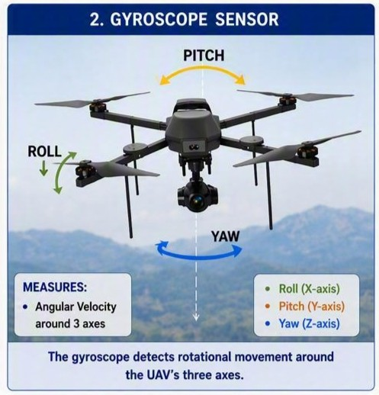
Gyroscope
    - Accelerometer
The accelerometer measures linear acceleration along the X, Y, and Z axes. It helps the flight controller determine:
- Changes in speed
- Direction of movement
- The direction of gravity, which assists in estimating the drone's tilt when combined with gyroscope data
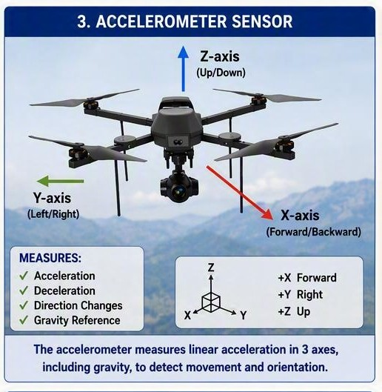
Accelerometer

    - Magnetometer
The magnetometer measures the Earth's magnetic field to determine the drone's heading.
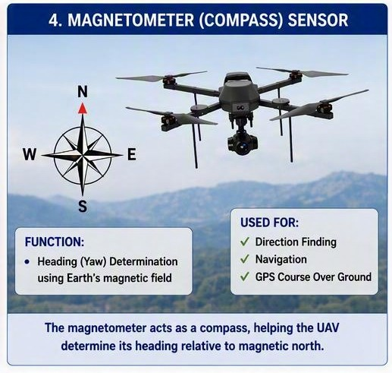
Magnetometer

    - Barometer
A barometer measures air pressure. Because atmospheric pressure changes with altitude, the flight controller can estimate changes in height.
Uses of Barometer:
- Altitude hold
- Smooth hovering
- Stable climbs and descents

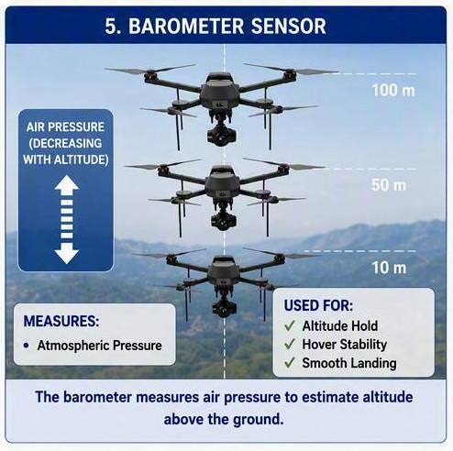
Barometer

    - GPS Receiver
The GPS receiver determines the drone's geographic position using signals from navigation satellites.
Functions of GPS Receiver:
- Position Hold
- Return to home
- Waypoint Navigation
- Flight Logging
Many drones also support other Global Navigation Satellite Systems (GNSS), such as GLONASS, Galileo, and BeiDou, to improve positioning accuracy and reliability.
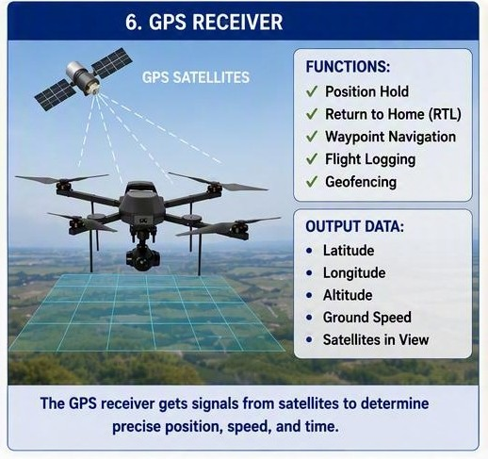
GPS Receiver

Fundamentals of UAV Flight Forces

For a UAV (Unmanned Aerial Vehicle) to fly safely and remain stable in the air, it must continuously balance several forces acting upon it. These forces determine whether the UAV takes off, hovers, climbs, descends, or moves in a particular direction. Understanding these forces is essential for learning the fundamental principles of drone flight and control.
Forces acting on UAV:
- Lift – The upward force generated by the propellers.
- Weight – The downward force due to the mass of the UAV.
- Thrust – The force produced by the motors and propellers that drives the UAV's movement.
- Drag – The aerodynamic resistance that opposes the UAV's motion through the air.
During flight, a UAV is primarily influenced by four forces: Lift, Weight (Gravity), Thrust, and Drag. Lift and thrust are generated by the drone's motors and propellers, while weight is caused by gravity and drag results from air resistance. The interaction of these forces governs the UAV's movement, stability, and overall flight performance.

Forces acting on Multirotor
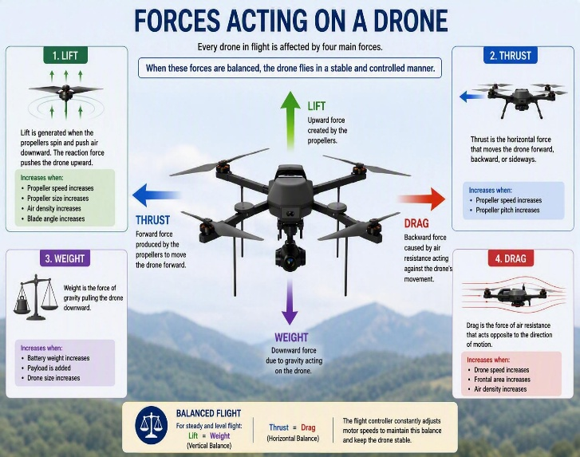
Forces acting on Multirotor

Lift: Lift is generated by the rotating propellers. As the propellers push air downward, an equal and opposite upward force is produced, causing the drone to rise. The amount of lift depends on propeller size, propeller design, motor speed, and air density.

Thrust: Thrust is produced by the rotation of multiple propellers. By varying the speed of individual motors, the drone can move upward, forward, backward, sideways, and rotate about its axes.

Drag: Drag is the aerodynamic resistance that opposes the drone's movement through the air. The frame, landing gear, payload, and rotating propellers contribute to drag, requiring additional power to maintain speed.

Weight: Weight is the downward force caused by gravity acting on the drone. The propellers must generate enough lift to overcome the drone's weight for take-off and sustained flight.

Forces acting on VTOL
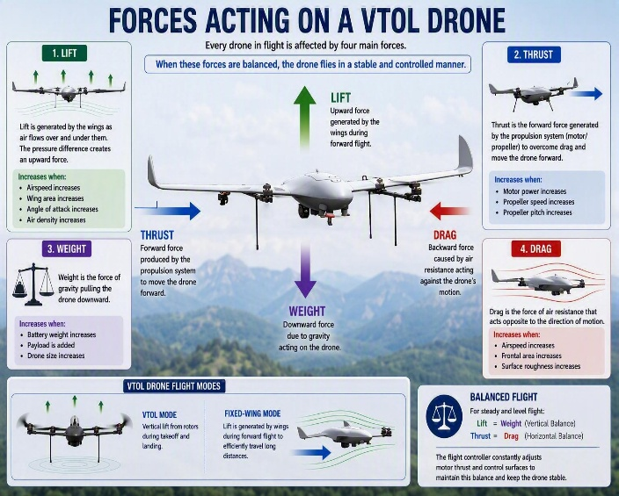
Forces acting on VTOL

Lift: During take-off, landing, and hovering, lift is generated by vertically oriented propellers, similar to a multirotor drone. During forward flight, the wings generate most of the lift, reducing the dependence on propellers and improving flight efficiency.

Thrust: During take-off, hovering, and landing, thrust is directed vertically to lift and control the aircraft. During forward flight, thrust is directed forward, propelling the aircraft while the wings generate lift.

Drag: VTOL drones experience drag from both their multirotor and fixed-wing components. During forward flight, the wings, fuselage, and exposed rotors create aerodynamic resistance, affecting speed and endurance.

Weight: Weight acts downward throughout all phases of flight. During vertical flight, propellers counteract the weight, while during forward flight, the wings generate lift to balance the aircraft's weight.

Forces acting on Fixed wing
Lift: Lift is generated by the wings. As the drone moves forward, air flows over and under the airfoil-shaped wings, creating a pressure difference that produces an upward lifting force. Continuous forward motion is required to maintain lift.

Thrust: Thrust is generated by one or more propellers or propulsion systems that push the aircraft forward. This forward motion allows airflow over the wings, enabling lift generation and sustained flight.

Drag: Drag opposes the forward motion of the aircraft. It is generated by the wings, fuselage, landing gear, and other external components. Greater drag requires more thrust and reduces flight efficiency.

Weight: Weight acts downward through the drone's center of gravity. The wings must continuously generate sufficient lift to counteract this force and keep the aircraft airborne.

  - Balancing the Forces of flight

The relationship between lift and weight determines whether the drone climbs, descends, or hovers.
- Lift = Weight: The drone hovers at a constant altitude.
- Lift > Weight: The drone climbs.
- Lift < Weight: The drone descends.
Similarly, thrust and drag determine forward motion.
- Thrust > Drag: The drone accelerates.
- Thrust = Drag: The drone maintains a constant speed.
- Thrust < Drag: The drone slows down.

- Flight modes on UAV
Flight modes are predefined operating states of a UAV that determine how the flight controller manages the aircraft's movement, stability, navigation, and level of pilot assistance. Different flight modes are selected based on the mission requirements and environmental conditions. Refer to the image below for better understanding.

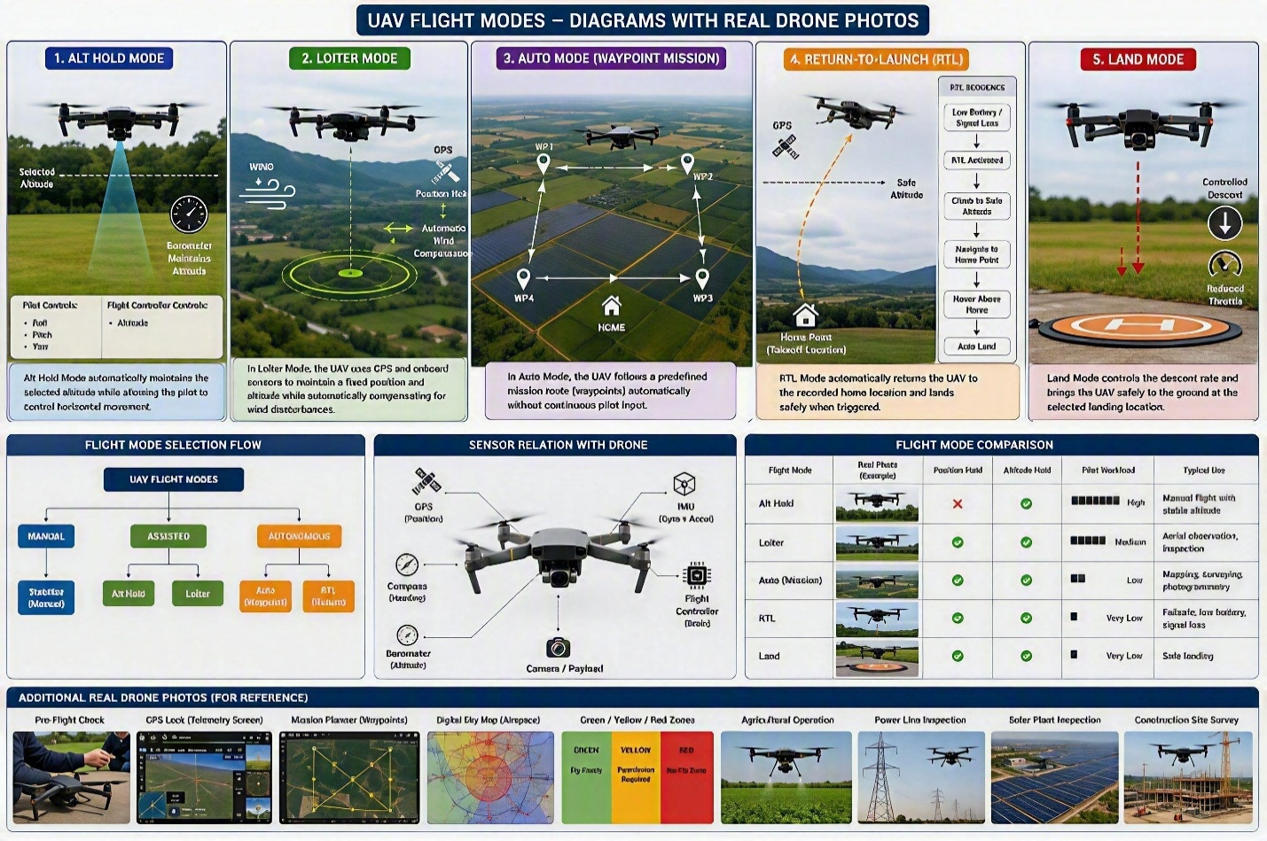
Flight modes

  - Loiter
- Uses GPS and onboard sensors to hold the UAV at a fixed position and altitude.
- The UAV automatically compensates for wind and minor disturbances.

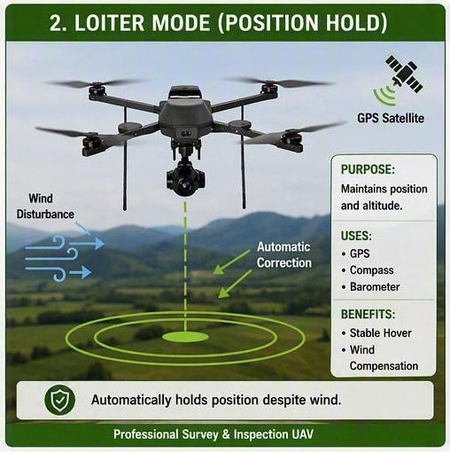
Loiter mode

  - Auto
- The UAV follows a pre-programmed flight path or mission without continuous pilot input.
- Waypoints and mission parameters are uploaded before take off.
- Commonly used for mapping, surveying, and autonomous missions.

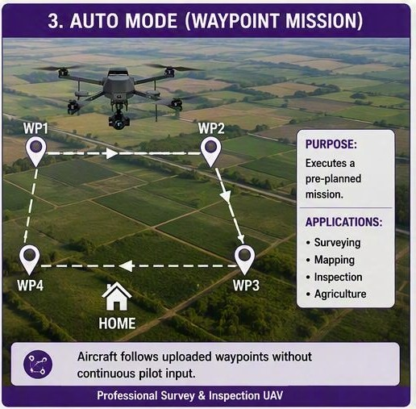
Auto mode

  - Land
- Land Mode is a flight mode in which the UAV automatically lands at its current location.
- Land Mode can be used during normal operations or in emergency situations, such as low battery.
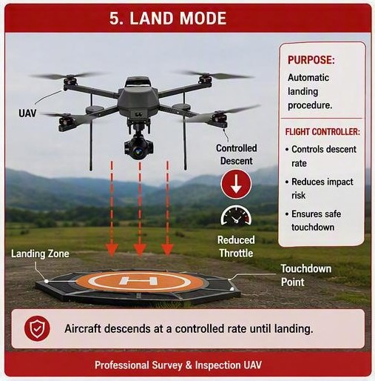
Land mode

  - RTL
- The UAV automatically returns to it take off location and lands.
- Can be activated manually or automatically during communication loss or low battery.

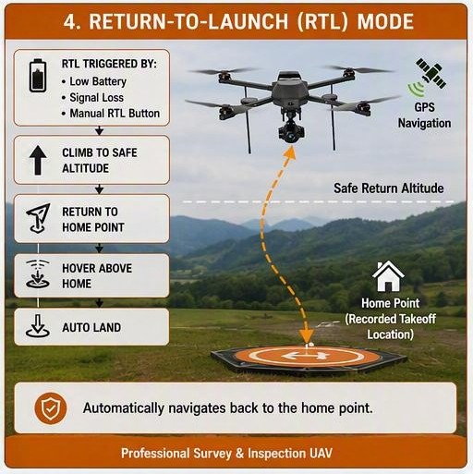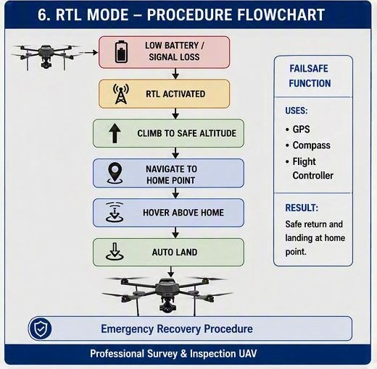
RTL mode

  - Alt Hold
- Alt Hold Mode is a flight mode that automatically maintains the UAV at a constant altitude during flight.
- The pilot controls the UAV's roll, pitch, and yaw, while the altitude is maintained automatically.
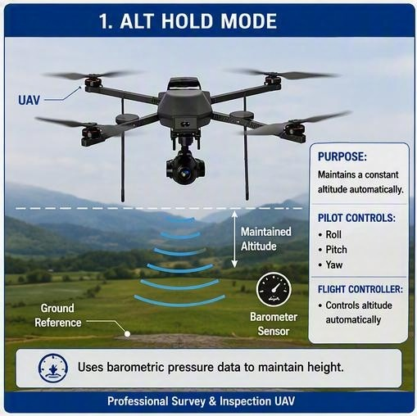
Alt Hold mode
- UAV Attitude and Axis Movement
To control its direction and orientation during flight, a UAV rotates about three principal axes: the longitudinal axis, lateral axis, and vertical axis. These rotational movements, known as roll, pitch, and yaw, enable the UAV to maneuver, maintain stability, and navigate effectively. The flight controller continuously adjusts motor speeds to control these movements and ensure stable flight.

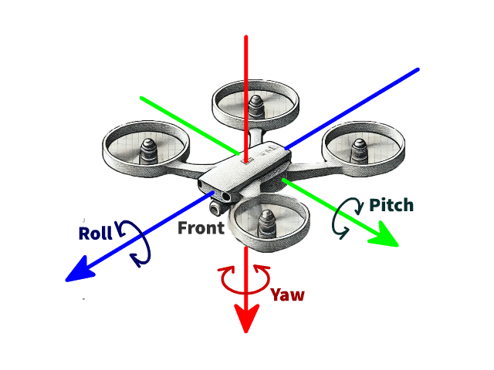
Rotational Movement of UAV

  - Roll
Roll is the rotation of the UAV about its longitudinal (front-to-back) axis. During roll, one side of the UAV moves upward while the opposite side moves downward, causing the aircraft to tilt left or right.

Working:
- Roll is controlled by increasing the speed of the motors on one side and decreasing the speed of the motors on the opposite side.
- If the left motors produce more thrust than the right motors, the UAV rolls to the right.
- If the right motors produce more thrust than the left motors, the UAV rolls to the left.
- Roll movement is mainly used for sideways motion and turning.
  - Pitch
Pitch is the rotation of the UAV about its lateral (side-to-side) axis. It changes the nose of the UAV upward or downward.
Working:
- Pitch is controlled by changing the thrust between the front and rear motors.
- Increasing the thrust of the rear motors while decreasing the front motors causes the nose to tilt upward.
- Increasing the thrust of the front motors while decreasing the rear motors causes the nose to tilt downward.
- Pitch enables the UAV to move forward or backward.
  - Yaw
Yaw is the rotation of the UAV about its vertical axis. It changes the direction in which the UAV is facing without changing its position.

Working:
- Yaw is controlled by creating a difference in torque between the clockwise (CW) and counterclockwise (CCW) rotating motors.
- Increasing the speed of one pair of motors and decreasing the speed of the opposite pair produces rotational movement.
- Clockwise and counterclockwise motor pairs balance each other's torque during normal flight.
- When this balance is changed, the UAV rotates left or right about its vertical axis.
- DGCA Regulations
The Directorate General of Civil Aviation (DGCA) regulates drone operations in India through the Drone Rules, 2021. To ensure safe use of Indian airspace, DGCA classifies the country's airspace into Green, Yellow, and Red Zones. Before every drone flight, operators should check the latest airspace map on the Digital Sky platform, as zone boundaries may change.
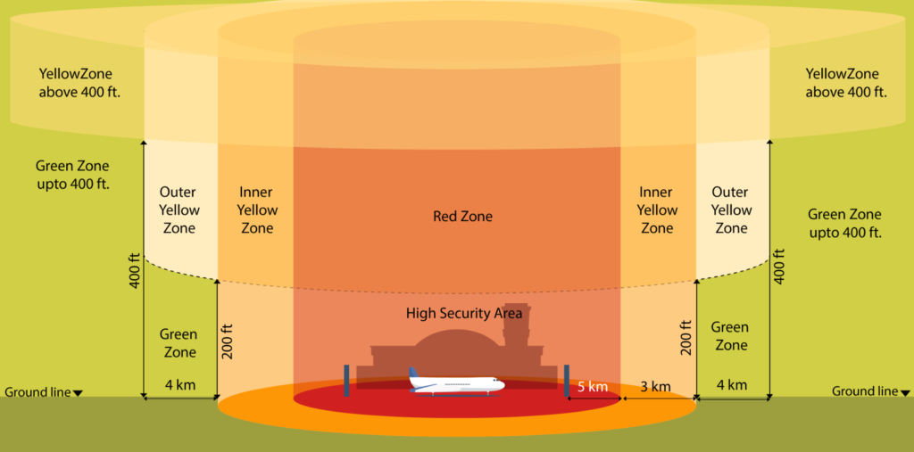
DGCA Drone Rules

  - Green Zone
The Green Zone is the airspace where drones can be flown without prior operational permission, provided the flight complies with DGCA rules.

Rules:
- No permission is required before flying.
- Maximum flying altitude is 120 meters.
- If the area is 8 km to 12 km from an operational airport, the maximum permitted height is 60 meters.
- The drone must remain within the pilot's Visual Line of Sight (VLOS).
- Example: Agricultural fields away from airports, Open farmland and villages, Survey areas in rural regions
  - Yellow Zone
A Yellow Zone is a restricted area where a drone can fly only after obtaining permission from Air Traffic Control (ATC).

Rules:
- Permission from ATC is mandatory.
- This zone includes areas within 5 km to 8 km of an operational airport.
- It also includes airspace above 120 meters in Green Zones.
- Fly only after receiving official approval.
- Examples: Areas between 5 km and 8 km from an operational airport, Airspace above the permitted height limit in a Green Zone, Certain controlled airspace near aerodromes.
  - Red Zone
A Red Zone is a highly restricted area where drone flying is prohibited unless special permission is obtained from the Central Government.

Rules:
- Flying is not allowed without special approval.
- These areas are reserved for security and safety.
- Unauthorized drone operations may result in legal action.
- Example: Military bases, nuclear power plant, international borders.

